EX.NO:03 | LEARNING MANAGEMENT SYSTEM
DATE:

1.AIM:
To design and develop a Learning Management System (LMS) web page using HTML, Bootstrap, and JavaScript that allows users to upload courses and take quizzes.
2.PROCEDURE:
Step 1: Create an HTML page and include Bootstrap for responsive design.
Step 2 : Design a form to input course title and description.
Step 3 : Use JavaScript to store course details and predefined quiz questions.
Step 4 : Display uploaded courses dynamically using DOM manipulation.
Step 5 : Provide a “Take Quiz” button for each course.
Step 6 : Implement quiz logic using radio buttons and JavaScript functions.
Step 7 : Calculate and display the quiz score after submission.
3.PROGRAM SOURCE CODE:
Lms.html
<!DOCTYPE html>
<html lang="en">
<head>
<meta charset="UTF-8">
<title>Responsive LMS with Quiz</title>
<meta name="viewport" content="width=device-width, initial-scale=1">
<link href="https://cdn.jsdelivr.net/npm/bootstrap@5.3.2/dist/css/bootstrap.min.css" rel="stylesheet">
<style>
body {
background-color: #f8f9fa;
}
.card {
transition: 0.3s;
}
.card:hover {
transform: scale(1.03);
}
</style>
</head>

<body>
<nav class="navbar navbar-expand-lg navbar-dark bg-dark">
<div class="container">
<a class="navbar-brand" href="#">My LMS</a>
</div>
</nav>
<section class="container text-center my-5">
<h1 class="fw-bold">Learning Management System</h1>
<p class="lead">Upload courses and take quizzes</p> </section><section class="container my-5">
<h2>Add Course</h2>
<div class="card p-4 shadow">
<form id="courseForm">
<div class="mb-3">
<input type="text" class="form-control" id="courseTitle" placeholder="Course Title" required>
</div>
<div class="mb-3">
<textarea class="form-control" id="courseDesc" placeholder="Course Description" required></textarea>
</div>
<button type="submit" class="btn btn-primary w-100">Upload Course</button>
</form>
</div>
</section>

<section class="container my-5">
<h2>Available Courses</h2>
<div class="row" id="courseContainer"></div>
</section>

<script>
const form = document.getElementById("courseForm");
const container = document.getElementById("courseContainer");

let courses = [];
form.addEventListener("submit", function (e) {
e.preventDefault();

const title = document.getElementById("courseTitle").value;
const desc = document.getElementById("courseDesc").value;

const quiz = [
{
question: "What is HTML?",
options: ["Programming Language", "Markup Language", "Database", "Operating System"],
answer: 1
},
{
question: "What does CSS stand for?",
options: ["Creative Style Sheet", "Cascading Style Sheets", "Computer Style System", "Color Style Sheet"],
answer: 1
},
{
question: "Which is used for responsive design?",
options: ["Flexbox", "Grid", "Media Queries", "All of the above"],
answer: 3
},
{
question: "Bootstrap is a?",
options: ["Framework", "Language", "Database", "Server"],
answer: 0
},
{
question: "Which tag is used for JavaScript?",
options: ["&lt;js&gt;", "&lt;javascript&gt;", "&lt;script&gt;", "&lt;code&gt;"],
answer: 2
}
];

courses.push({ title, desc, quiz });
displayCourses();
form.reset();
});

function displayCourses() {
container.innerHTML = "";

courses.forEach((course, index) => {
container.innerHTML += `
<div class="col-md-4 col-sm-6 mb-4">
<div class="card shadow h-100">
<div class="card-body d-flex flex-column">
<h5>${course.title}</h5>
<p>${course.desc}</p>
<button class="btn btn-success mt-auto" onclick="startQuiz(${index})">
Take Quiz
</button>
<div id="quiz-${index}" class="mt-3"></div>
</div>
</div>
</div>
`;
});
}

function startQuiz(index) {
const quizDiv = document.getElementById(`quiz-${index}`);
const quiz = courses[index].quiz;

let quizHTML = "";

quiz.forEach((q, i) => {
quizHTML += `
<div class="mb-3">
<p><strong>Q${i + 1}. ${q.question}</strong></p>
`;

q.options.forEach((option, optIndex) => {
quizHTML += `
<div class="form-check">
<input class="form-check-input" type="radio"
name="question${index}-${i}" value="${optIndex}">
<label class="form-check-label">${option}</label>
</div>
`;
});
quizHTML += `</div>`;
});

quizHTML += `
<button class="btn btn-primary w-100"
onclick="submitQuiz(${index})">Submit Quiz</button>
<div id="result-${index}" class="mt-3"></div>
`;

quizDiv.innerHTML = quizHTML;
}

function submitQuiz(index) {
const quiz = courses[index].quiz;
let score = 0;

quiz.forEach((q, i) => {
const selected = document.querySelector(
`input[name="question${index}-${i}"]:checked`
);

if (selected && parseInt(selected.value) === q.answer) {
score++;
}
});

document.getElementById(`result-${index}`).innerHTML = `
<div class="alert alert-info">
Your Score: <strong>${score} / ${quiz.length}</strong>
</div>
`;
}
</script>
</body>
</html>
4.SAMPLE INPUT/OUTPUT
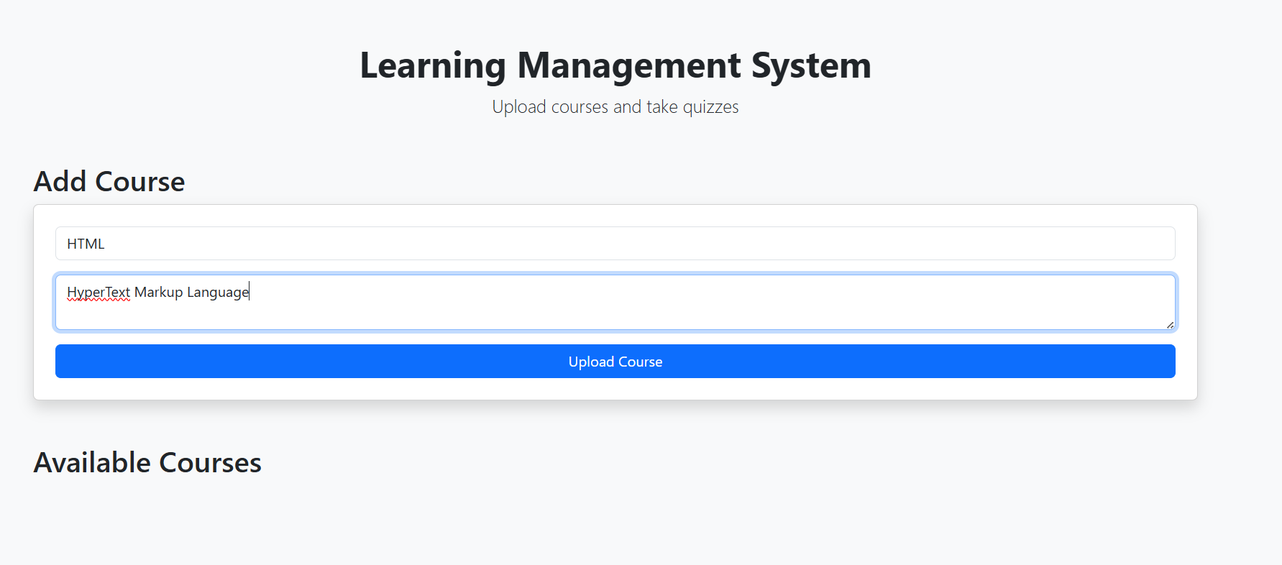
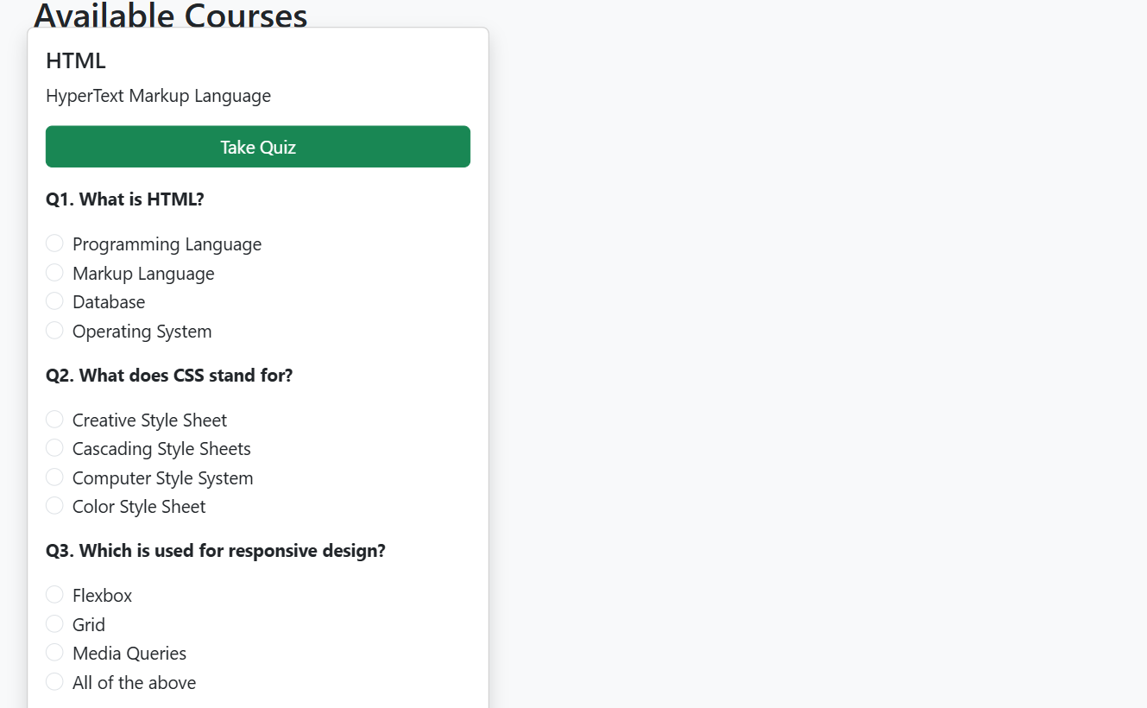

After Submit a quiz score will show
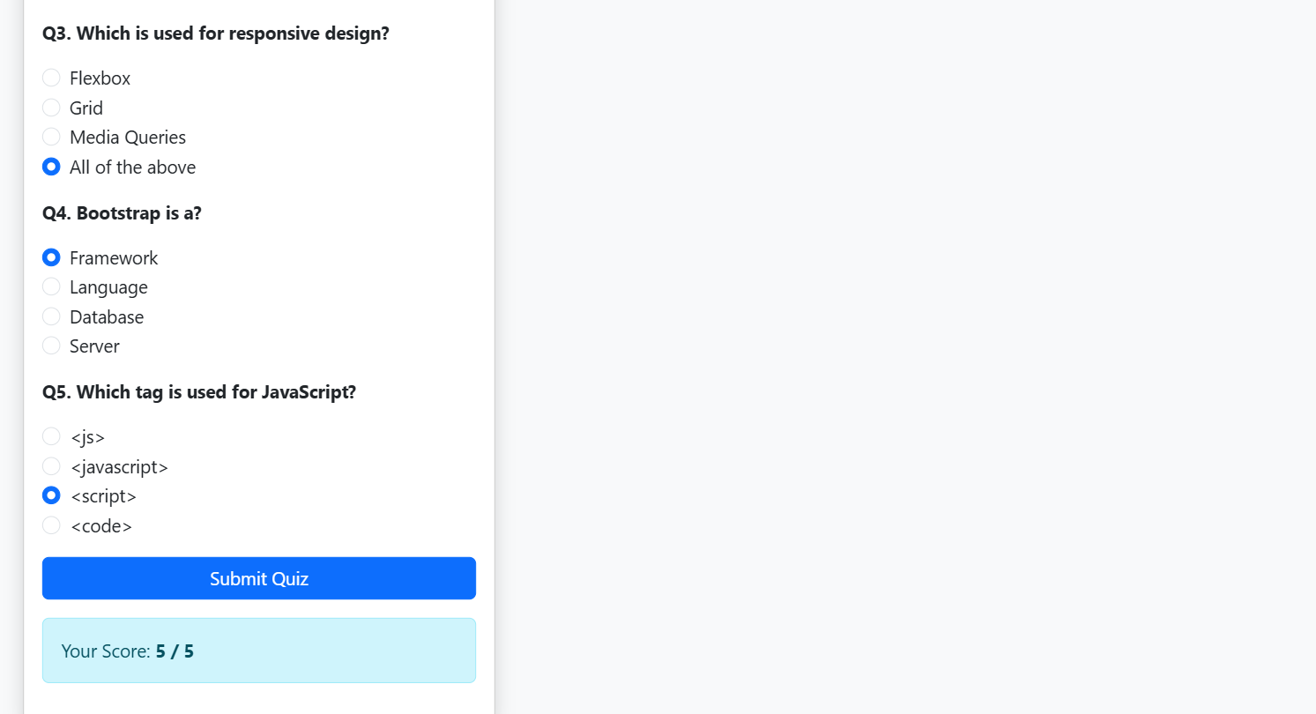

5.RESULT:
The Learning Management System web application was successfully created. Users can upload courses, attempt quizzes, and the quiz score is displayed after submission.

